QUESTION1 :  
function capitalizer(text){

const myArray = text.split(" ");

newarr = [];

for ( let i = 0; i < myArray.length; i++){

 newarr[i] = myArray[i].charAt(0).toUpperCase() + myArray[i].slice(1);

 }

 const result = newarr.join(" ");

 console.log(result);

}

Output:  
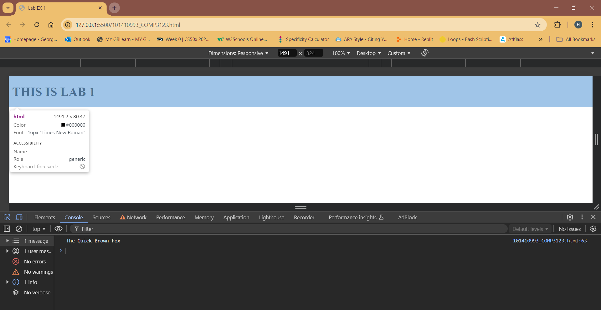

QUESTION 2:  
function findlargest(arr){

    if (arr.length === 0){

        return "array is empty"

    }

    let largest = arr[0];

    for (let i = 1; i < arr.length; i++) {

        if(arr[i] > largest)

        {largest = arr[i];}

    }

  console.log(largest);

}

arr1 = [1000,510,440]

findlargest(arr1);

output:  
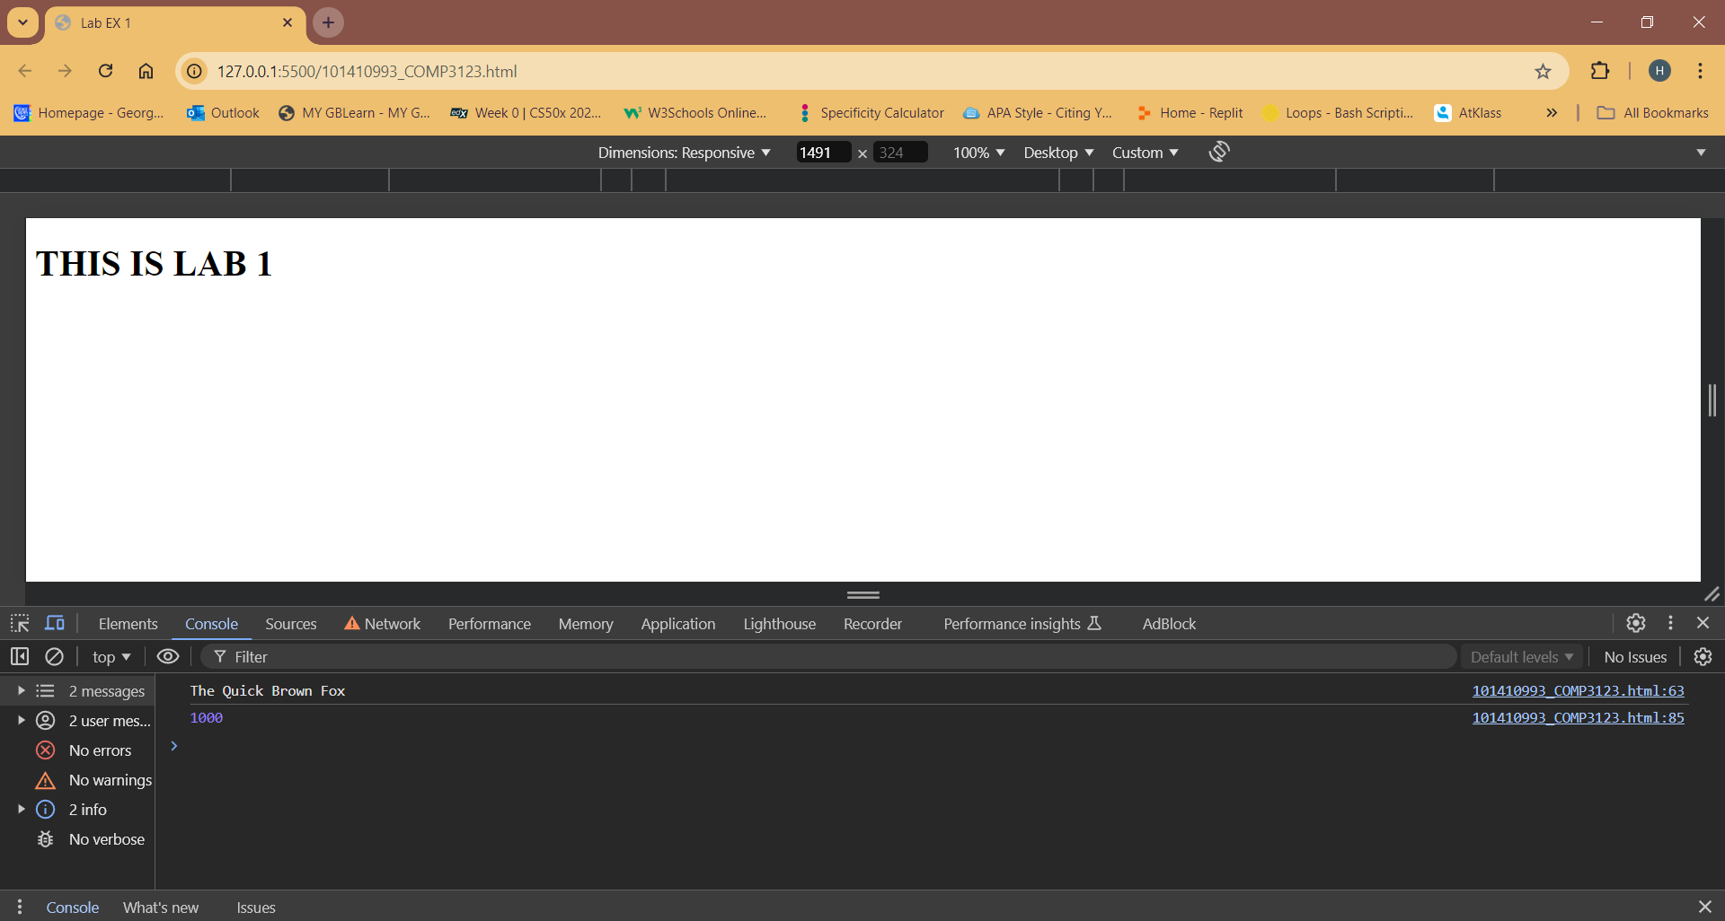

Question 4:  
function anglefinder(angle) {

    if (angle < 0 || angle > 180) {

        return 'Invalid angle';

    } else if (angle < 90) {

        return 'Acute angle';

    } else if (angle === 90) {

        return 'Right angle';

    } else if (angle < 180) {

        return 'Obtuse angle';

    } else if (angle === 180) {

        return 'Straight angle';

    }

}

console.log(anglefinder(47))

console.log(anglefinder(90))

console.log(anglefinder(145))

console.log(anglefinder(180))

output:  
